Exploring Sources for The Sound of Freedom

This is a recorded PowerPoint presentation where I am talking through the slides. I set out to make it as interactive as possible. For that reason, I thought it would be useful for these notes to be sent out in advance, so that teachers could get a ‘heads up’ on questions that will be asked.
Best way to run the PowerPoint: Click on ‘Slide Show’. Then click on ‘Set up show’. Then under ‘Advance Slides’ select manually. That way you can control the length of time for each slide.

Link to History Curriculum for Fifth and Sixth Classes: Politics, Conflict and Society
Strand Units
- To engage in simple studies of some of the more important aspects of periods during which political changes or movements had an important influence on the lives of people in Ireland.
- To explore, discuss, compare and develop some simple understanding of the attitudes, beliefs, motivations and actions of differing individuals and groups of people at this time.
No. | PowerPoint
2 | Do you know any well-known events that happened during these years: 1914-1919?  Some possible answers:  World War 1 1914-18 1916 Rising 1918 election 1919 First Dáil  1919 Start of the War of Independence  In slide no 3 I will be briefly tying the book in with WW1, 1916 Rising and 1918 Election.
16+ | A series of slides are shown and the children are asked if they are primary or secondary sources. 16, 17,18 are primary 19, 20 are secondary and 21 is primary.
22 | Pause the presentation if you are doing the optional activity based on primary and secondary sources. If you are, print out the primary and secondary sources attached to email. Some could be photocopied.  When I did this workshop, I provided two folders labelled ‘primary’ and ‘secondary’.  I distributed the sources and asked the students to look at what they were given carefully and when I called out ‘sources’ they had to come up and put the source into the right folder. I realise everything has changed since Covid-19, but I’ve provided the sources in case you want to do a variation of this.
23 | What do they think the word ‘bias’ means? (Looking at bias in the sources.)
25 | Why do you think it was important for me to research the area where my story took place?
28 | What do you think a cooper made? What do you think a milliner made?’
29 | Question: ‘What did a blacksmith do?’
Follow-Up Activity
An activity based on the topic of ‘aeraíocht’ follows. In the ads for the Aeraíochta there are references to ‘Irish Time’ and ‘Old Time’ so I’m including an article about that if you would like to explore that further.
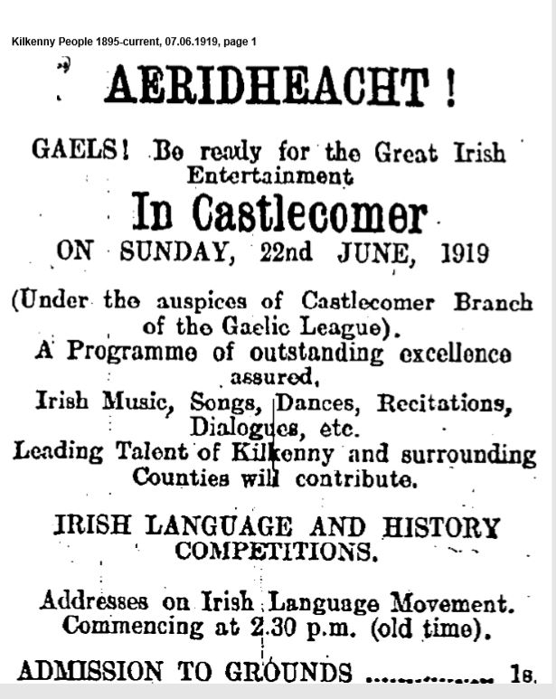
Follow-Up Activity Name ________________________
Can you list five different ways that the Castlecomer aeraíocht is promoting the idea of being Irish?
_________________________________________________________________________________________________________________________________________________________________________________________________________________________________

What persuasive language is being used in the advertisement for the Castlecomer aeraíocht to encourage people to come to this event?
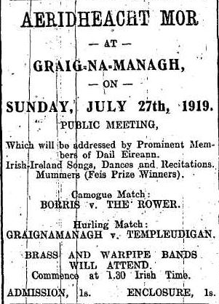
______________________________________________________
Given what was going on in Ireland at the time, why do you think that the advertisement for Graiguenamanagh Aeraíocht did not list the speakers’ names?

_________________________________
What does the word ‘recitation’ mean?

What does the word ‘mummer’ mean?
____________________________________________________________________________________________________________

