Notable Achievements
- As part of our Door to Door delivery service, 4,839 books were delivered to 1,109 Cocooners across the county.
- Use of our online services grew exponentially with a 49% increase in use of eBooks, and a 45% increase in use of eAudiobooks amongst registered members.
- 10,000 Bookville Activity Books distributed to all 88 primary schools across Kilkenny as part of our annual Bookville Kilkenny Festival.
- 47,254 books were borrowed through Book and Browse and Contact and Collect.
- As part of our Right to Read Literacy Initiative, Staff recorded 270 Storytime’s which had 66661 views on Facebook.
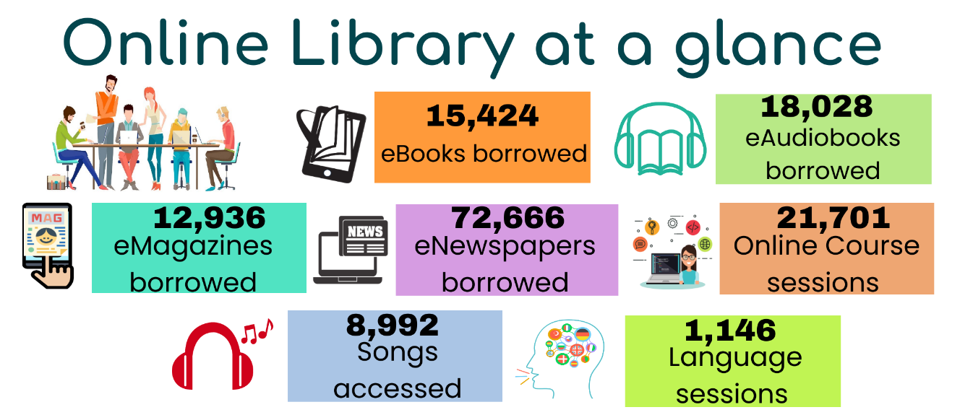
Responding to Needs: A Hybrid Library Service
In response to the challenging circumstances the library service had to respond and adapt rapidly to ensure services were delivered to the individuals and communities we serve. Throughout the year all public health guidelines were implemented allowing us to provide services in a safe and controlled manner transforming our traditional service into a flexible hybrid model.
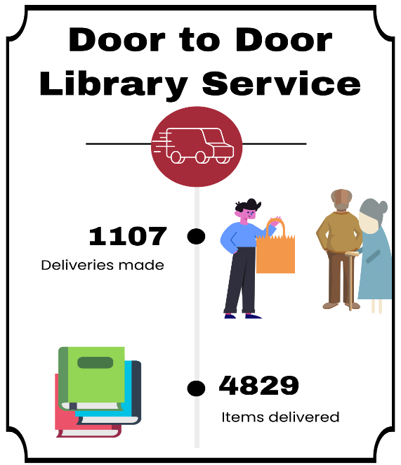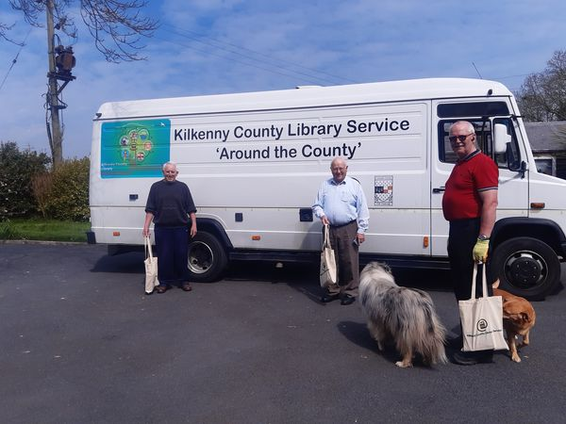
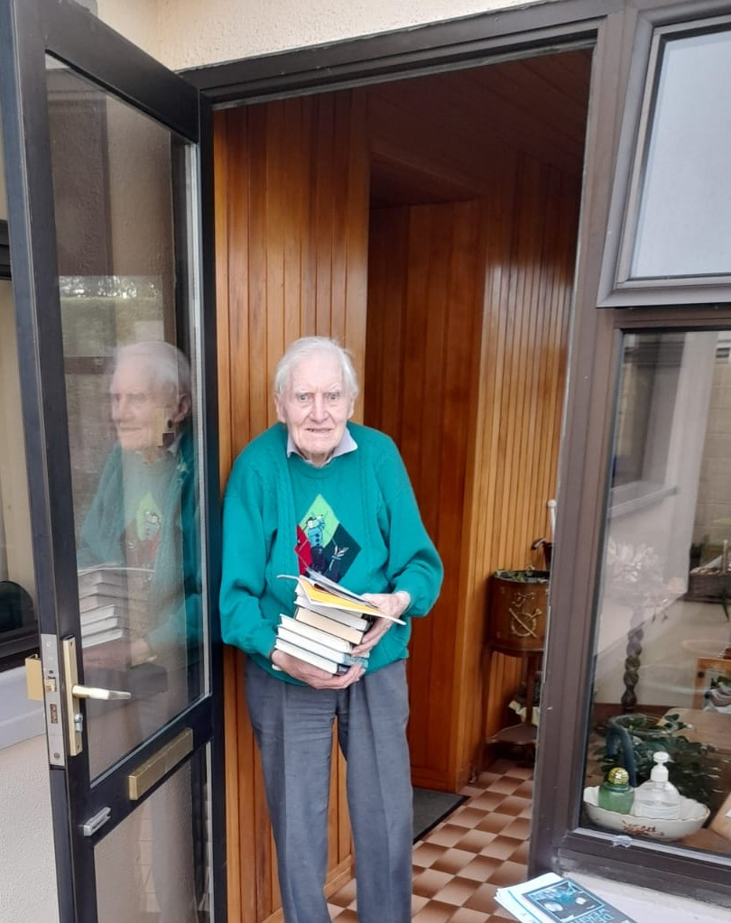
Staying Connected
- Door to Door: Each library contacted their local cocooning members by phone to offer a personalised service. Staff then carefully selected suitable books and packed books and other small gifts. These were then delivered directly to the door of members’ homes and nursing homes across the County. The service helps the most vulnerable in our communities by keeping their minds active and engaged.

- Contact and Collect/Book and Browse: We tailored two new service delivery models to suit our customer’s needs, introduced under different phases of the restrictions. Book and Browse allowed members to pre-book 30-minute slots to access the library in limited numbers. Contact and Collect was offered a pre-booked pick up service at the library door.
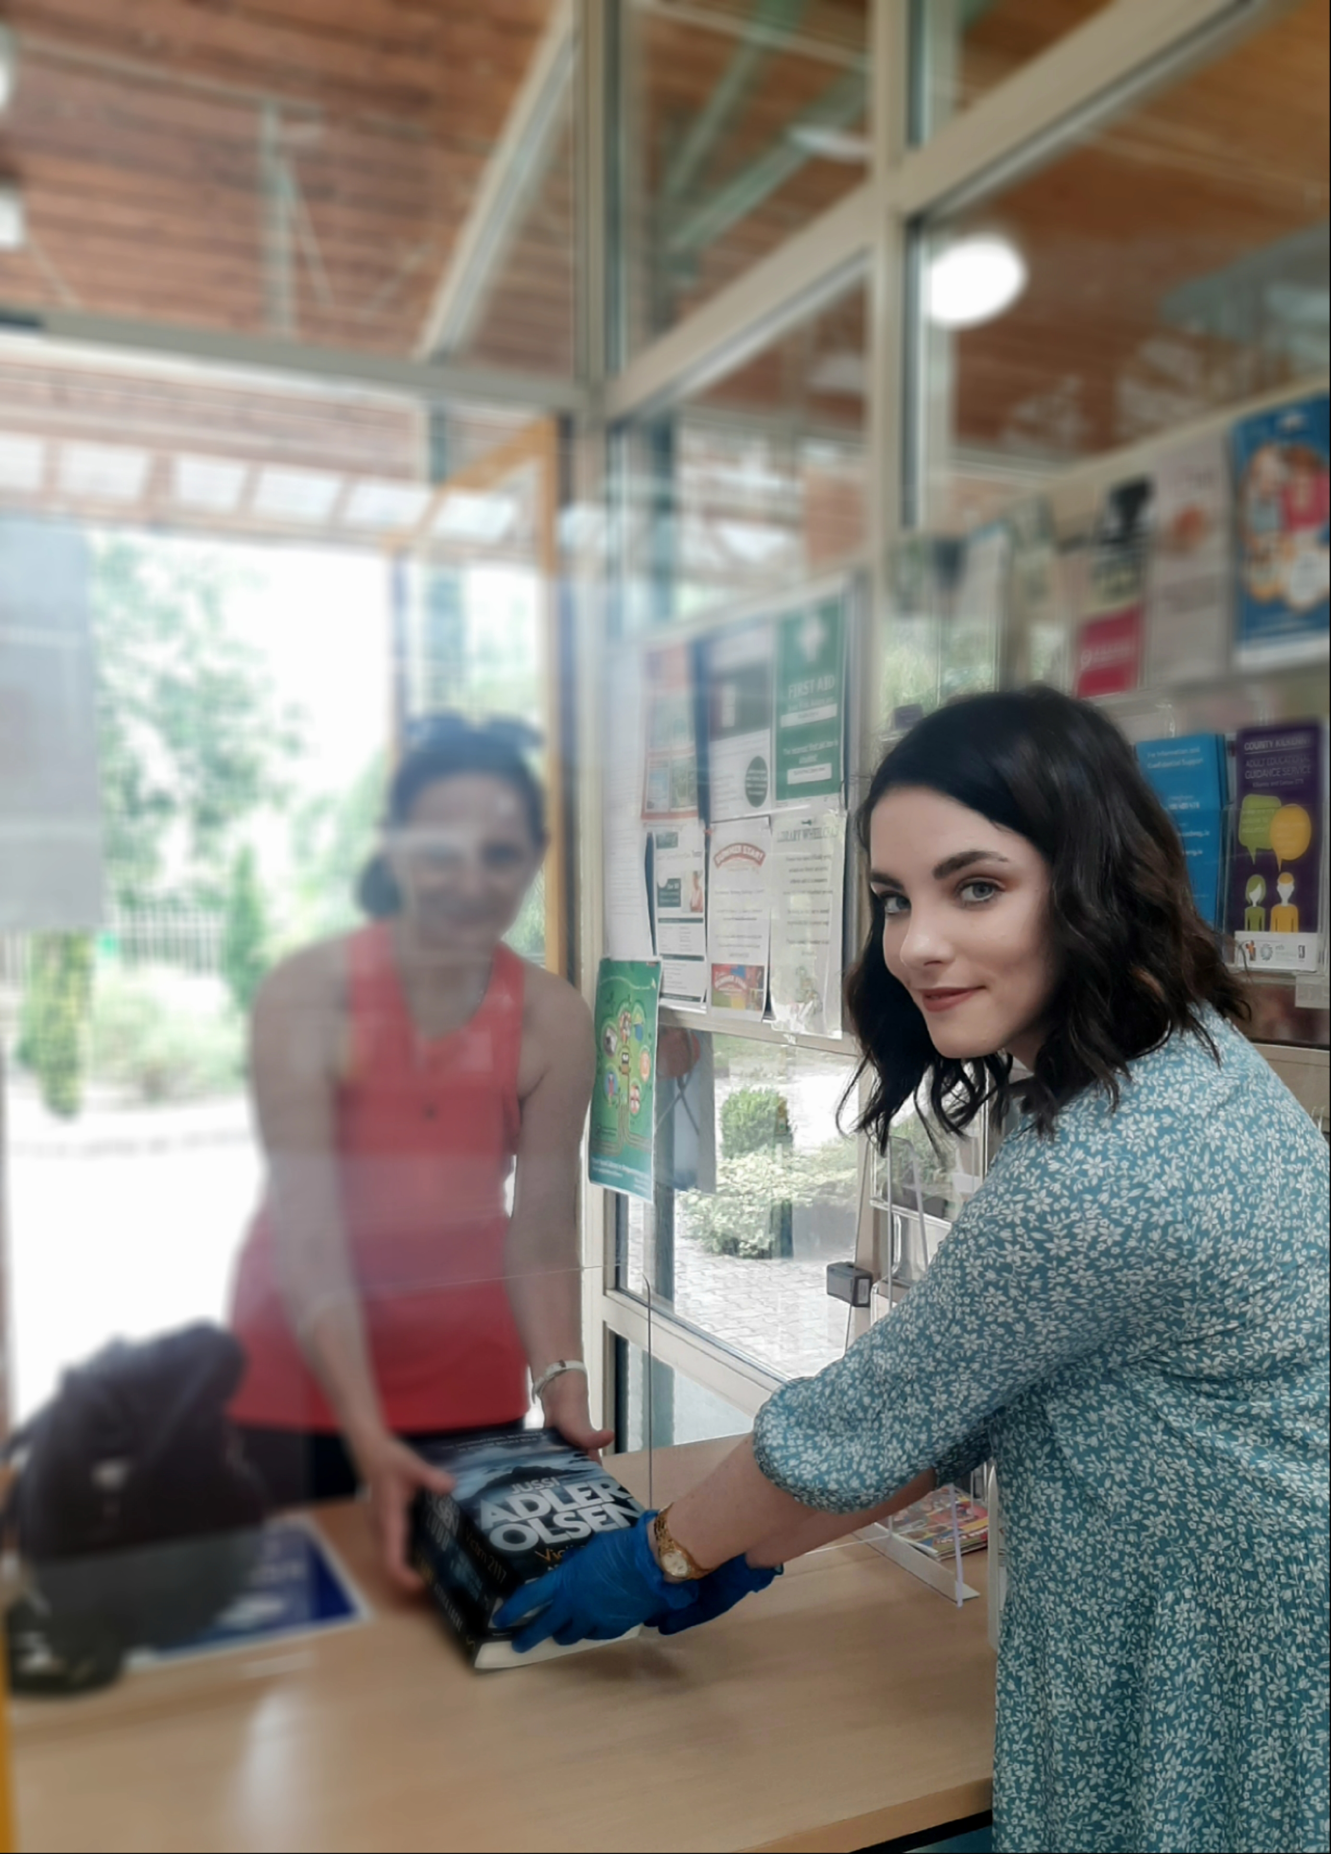
- Community Call: Library staff supported the community call helpline throughout the year and the Contact tracing service of the HSE.

Programming
From mid-March, we transitioned our programming from physical to online, and the library service took a pivotal role in developing and supporting programmes and initiatives as part of the Governments Community Wellbeing Campaign.

Community Wellbeing Campaign
- A Time to Relax: Mindfulness series with strands for both adults and children, offering people practical tools and simple ideas to improve overall wellbeing. Over 480 people engaged with these.
- A Time to Remember: A project designed to gather memories of this time for a special collection on Kilkenny Digital Archive.
- Age Friendly Programme of events were adapted for our online programme and ran throughout the year, in line with our commitments under the Age Friendly Kilkenny strategy. We held 37 events, including Flower Arranging, Chair Exercises, Walking workshops and Christmas Crafts.
- Healthy Ireland: Over 180 people have attended our Healthy Ireland events in February with included walking groups, Grow it Yourself workshops, Mindfulness for exams and a musical memory singalong. Additional physical and digital resources on topics such as healthy eating, wellbeing and mental health, physical activities and parenting were purchased for each of our libraries in Kilkenny.
- Virtual Book club -following the success of our involvement in KCLR Radio Book club over the summer, a virtual book club for adults has been developed and there are currently 85 members participating.
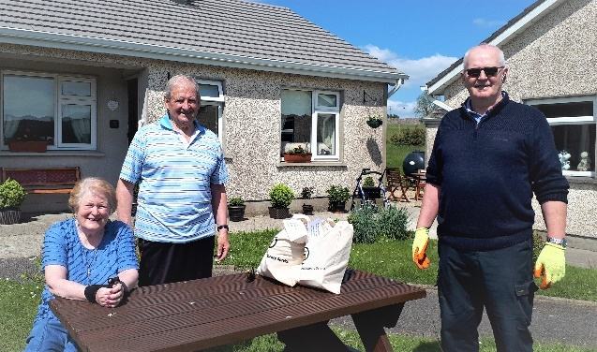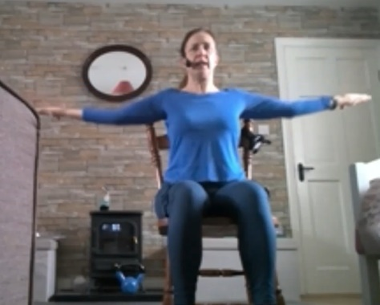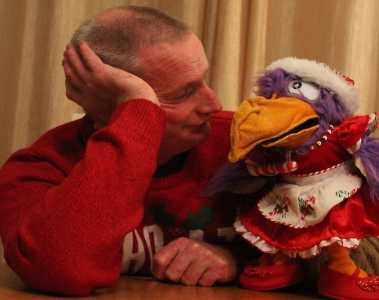
Door to Door deliveries May 2020 Chair Exercises with Bridget Children’s activities with Denis & Polly

Keep Well Campaign
- Dial A Story freephone service offered people an opportunity to listen to a collection of locally written stories reading by Library staff.
- Light Up Your Nights Campaign ran through Winter, with a Winter reading challenge, series of online workshops for all ages, and Christmas Craft Packs being delivered through our Door to Door service.
- Encouraging Reads Literacy Campaign offered Music Therapy for ASD Units, ASD Resource packs for all ASD units, and a collection of short video guides for our online services.

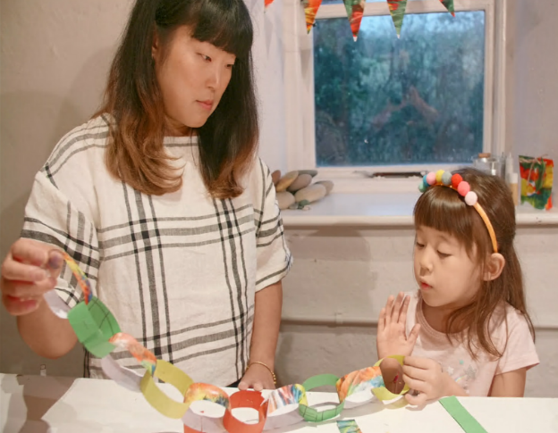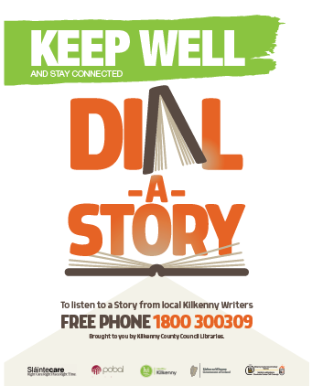
Majella reads online storytime for schools Zoe Wong provided online craft workshops Dial a Story Freephone line
Information and Communication
We utilised our website and social media platforms to maintain communication and engage out to people. This allowed us to promote and market the library’s offering in the online environment. For example, our staff created, recorded, edited and posted 270 videos of story times and book recommendations, which were viewed 66,661 times in our Facebook platform.

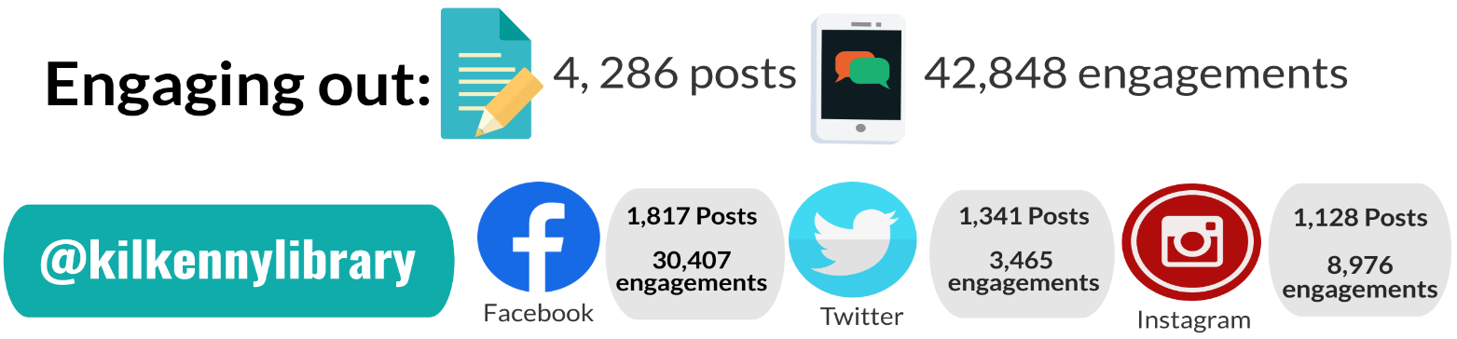

Community and Culture
- As part of the Creative Ireland 2020 programme, we delivered a very successful Bookville Festival to 88 schools with 10,000 copies of our Bookville Activity Book distributed.
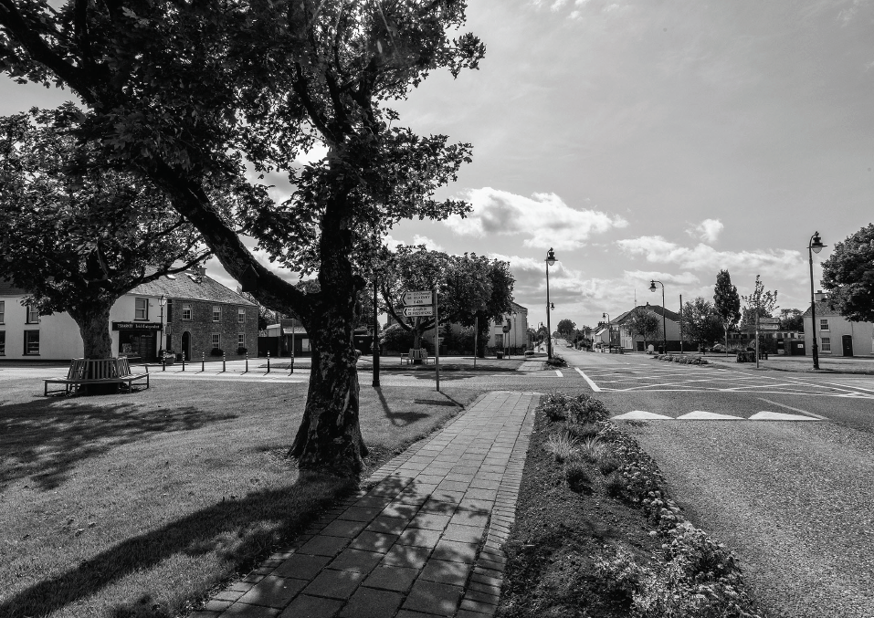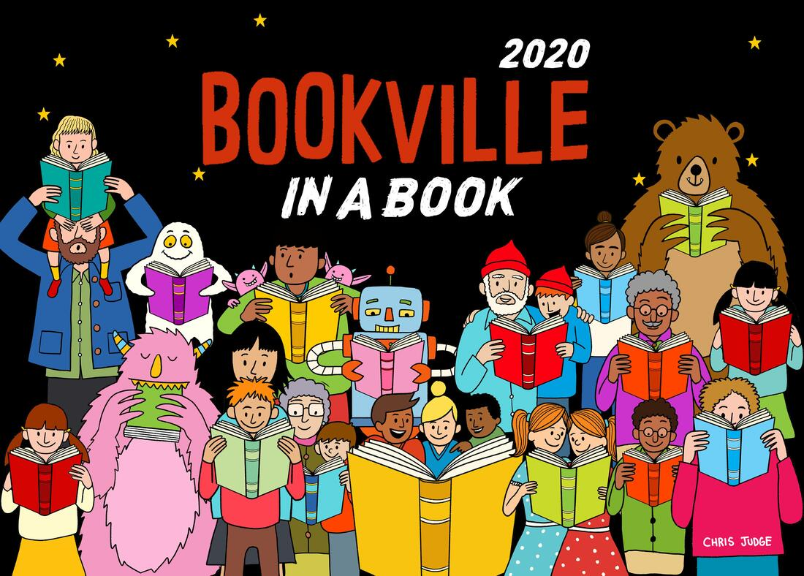
- As part of the Library Decade of Centenaries, library staff researched and developed content of local interest which was made available via podcasts, commissioned photographs of decade themed sites and developed decade themed learning materials for children.
- Hear our Story Project: Staff developed a series of online podcasts to give people confined to home a taste of Kilkenny City and County’s rich history and heritage. Themes included - Woodstock House and Estate, the Cuffes of Desart, and The Spanish Flu in Kilkenny.

Reading and Literacy

Kilkenny Library Service is at the forefront of supporting and developing literacy skills, reading, creativity, innovation and helping people realise their full potential. We also delivered events and activities in digital format to promote reading and creativity.

- National Spring into Storytime Campaign took place over April and May this year in a digital format, continuing to bring story times to children and families to keep literacy levels from declining. Staff developed 48 podcasts and videos to share with our younger library members. These had over 4,419 views and 1658 engagements throughout the campaign.
- National Summer Reading campaign ran throughout July and August this year. We tailored this years’ challenge by increasing access to more eBooks and eAudiobooks for children, and ran a programme of story times and quizzes online.
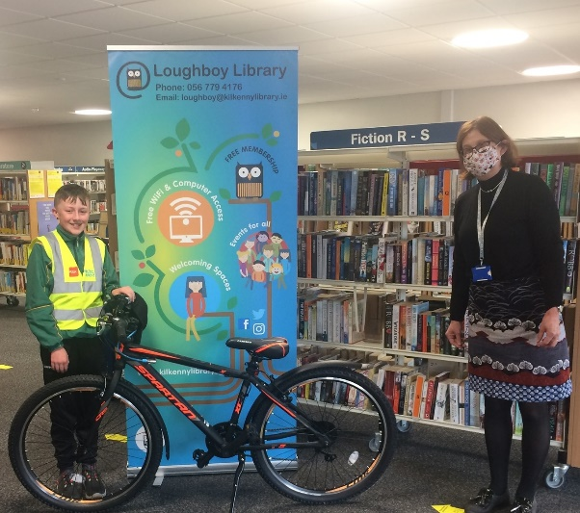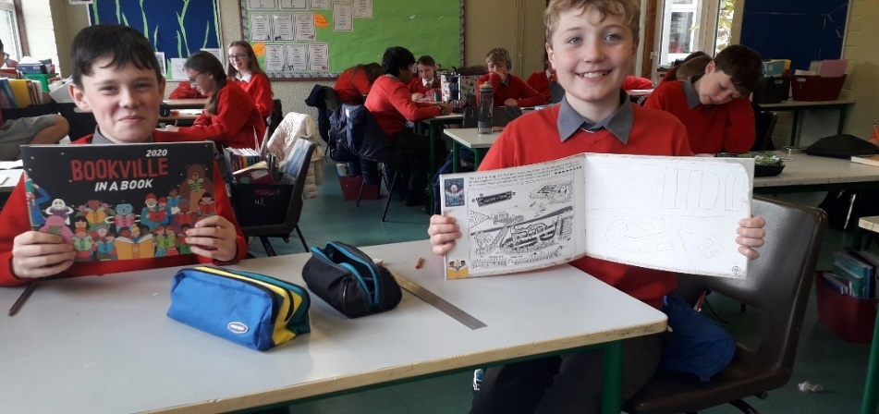
Roibeárd MacKenzie winner of a new bicycle Children at St. Canice’s N.S. with their Bookville Activity book.
as part of our Summer Stars Reading Challenge.

- Our mobile library has commenced service to over 20 primary schools across the county, delivering over 3,000 books in November. Significant investment has been made in reading resources and literacy stock suitable for all ages.
Moneenroe NS receiving Class novels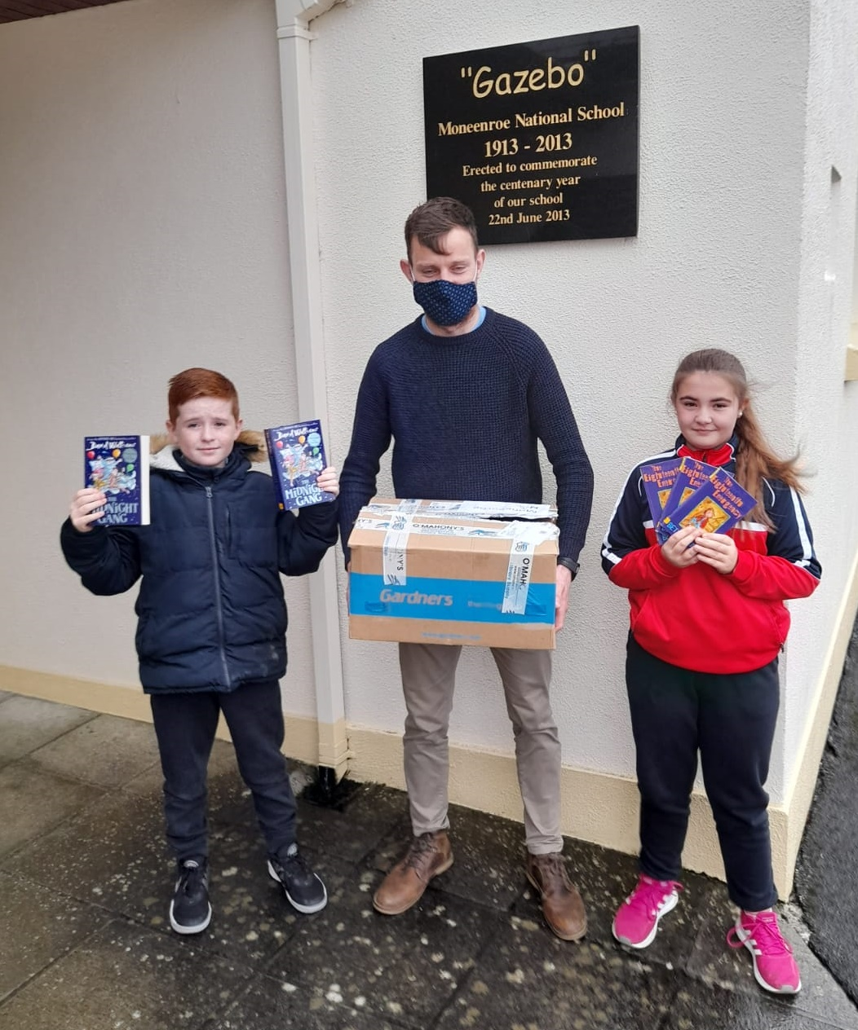
- We continued to support our Work Matters initiative across the network.
- We continued to work in partnership with both current and new partners, including The Design and Crafts Council, Kilkenny Carlow ETB, Kilkenny County Childcare Committee, Kilkenny Education Centre, Healthy Kilkenny, HSE, Music Generation, Calmast WIT.
- The service continues to participate and engage with national and local festivals and programmes including: Heritage week, Science week, Bealtaine, Savour Kilkenny, Seachtain na Gaeilge, Yulefest, Culture Night, Kilkenny Day, National Poetry day, Decade of Centenaries.
Service Development and Infrastructure
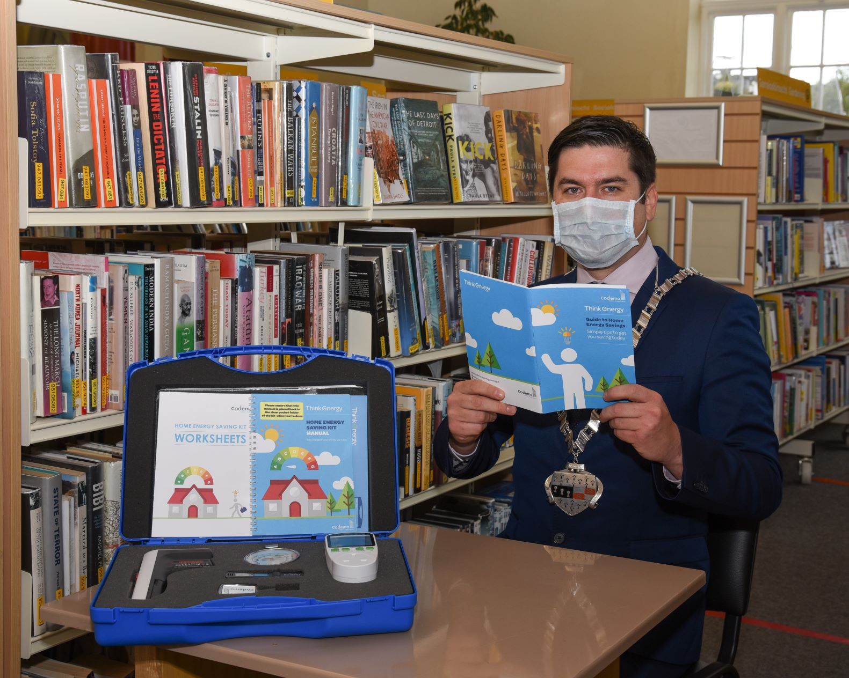
To ensure public health guidelines were adhered to in a safe and controlled manner, our buildings were assessed and adaptions made where required.
- Progression of capital projects in Kilkenny City and Thomastown.
- Investment in new technologies to innovate and make accessible services both in branch and digitally.
- Invested resources to expand our digital offering in new platforms, e.g.Freegal music, PressReader, and Comics Plus .
- Home Energy Saving Kits were rolled out to all libraries in Kilkenny in partnership with Kilkenny County Council Environmental Department.
- Our 3D printer was lent to local company, Print, Copy and Go to serve the community by making much needed PPE face shields.
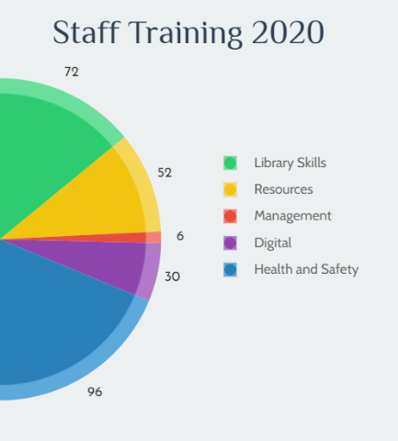
Workforce
Kilkenny Library Service works to contribute to the vitality and success of its public libraries and the diverse community they serve by positioning the library staff to be proactive and customer focused. 256 training and development courses were undertaken this year in response to emerging need and to plan for future service delivery. Progress commenced on our workforce plan recruitment.

